Assignment 3

1. Find the Student details and Placement details using NATURAL JOIN.

mysql> select * from Student natural join PlacementDrive;

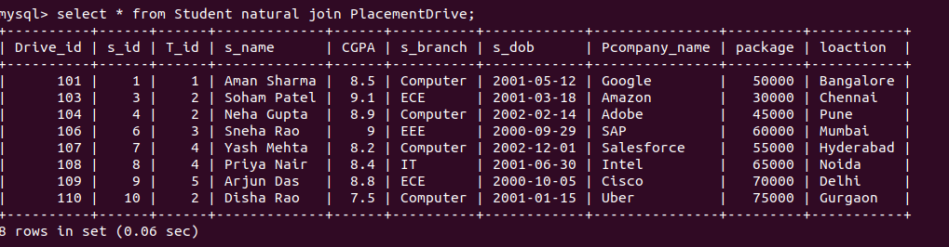

2. Find all the student details with company_name who have conducted in same drive

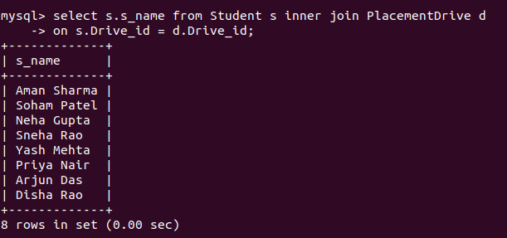

3. List all the Student name and Student branch of Student having package 5 LPA
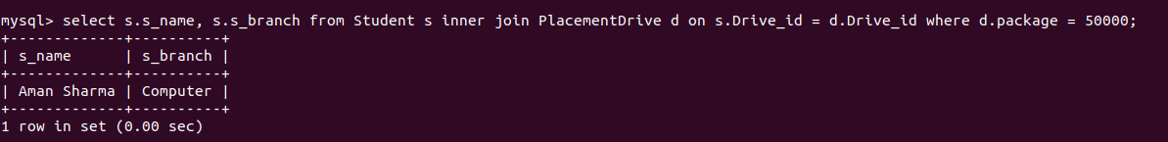

4.List all the student names ,company_name having T_fee more than 11000

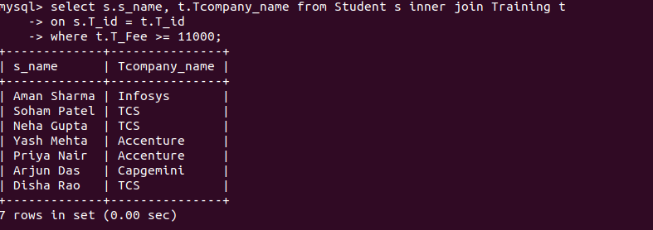

5. Display all training details attended by “Soham Patel” in year 2021

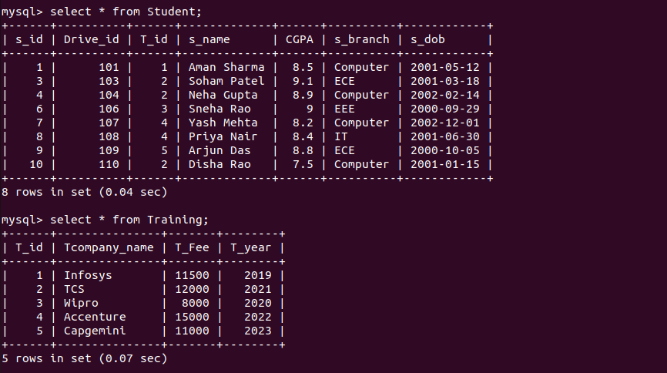
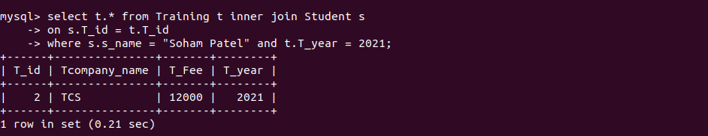

6. list the total number of companies who conduct training before 2021


7. List the students name with company Google and location Bangalore



8. Find the names of all Students who have joined TCS‘ training in 2021 .
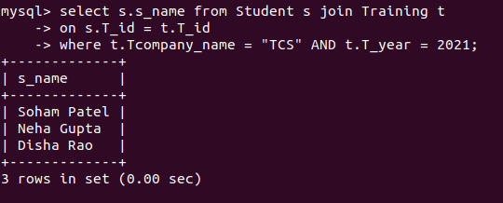

9. Create a view showing the Student and Training details.

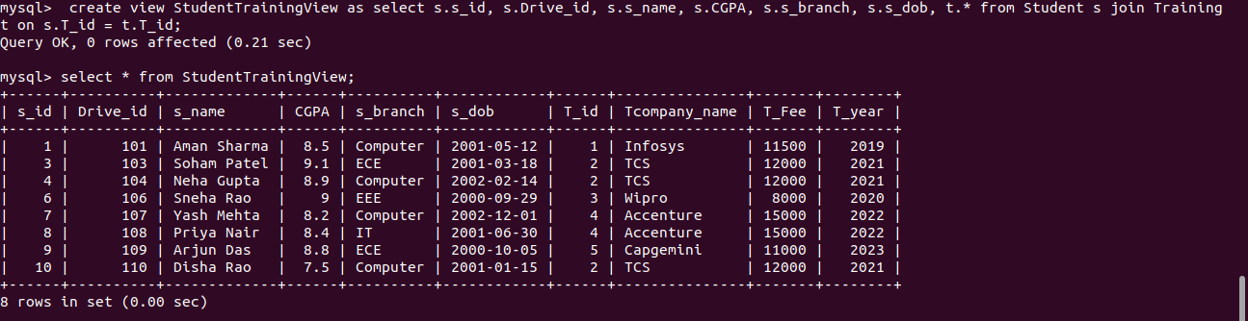

10. Perform Manipulation on simple view-Insert, update, delete, drop view.



Insert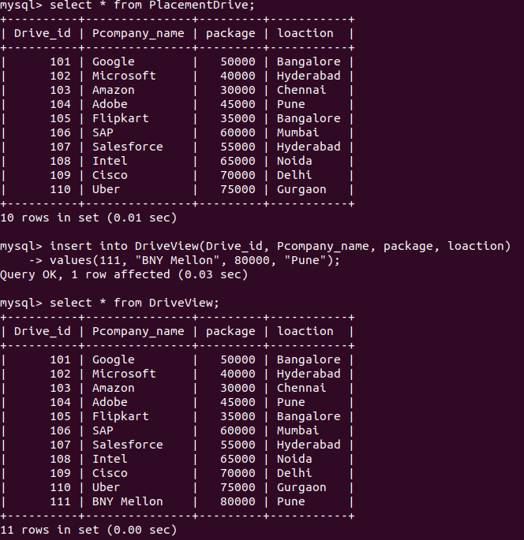

Update

update DriveView
-> set package = 95000
-> where Drive_id = 101;

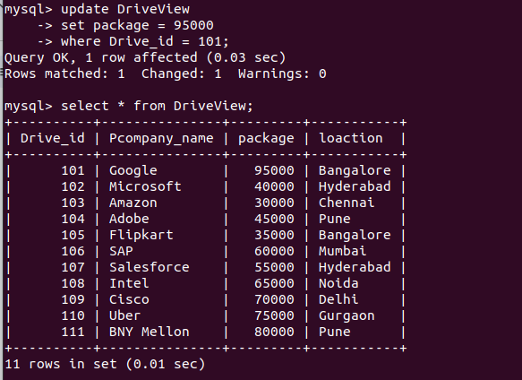

Delete
delete from DriveView
-> where Drive_id = 109;

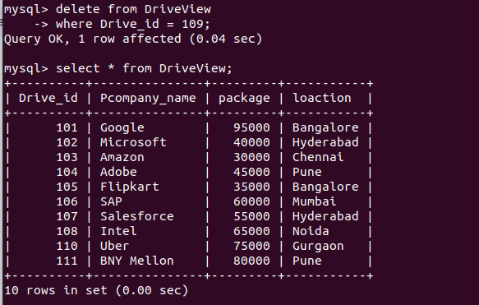

Drop

drop view DriveView;

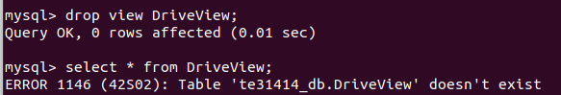

JOINS

CREATE TABLE departments (
department_id INT PRIMARY KEY,
department_name VARCHAR(50)
);

INSERT INTO departments (department_id, department_name) VALUES
(10, 'HR'),
(20, 'Finance'),
(30, 'IT'),
(40, 'Marketing');

CREATE TABLE employees (
employee_id INT PRIMARY KEY,
name VARCHAR(50),
department_id INT,
FOREIGN KEY (department_id) REFERENCES departments(department_id)
);

INSERT INTO employees (employee_id, name, department_id) VALUES
(1, 'Alice', 10),
(2, 'Bob', 20),
(3, 'Charlie', NULL),
(4, 'David', 30),
(5, 'Eve', 20);
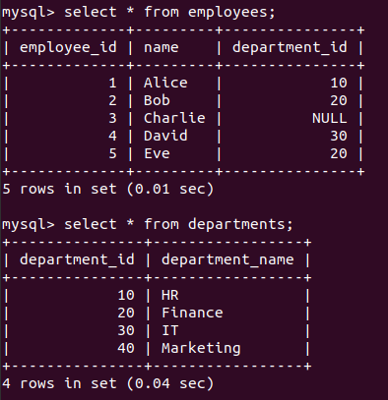

INNER JOIN
SELECT e.name, d.department_name
FROM employees e
INNER JOIN departments d ON e.department_id = d.department_id;

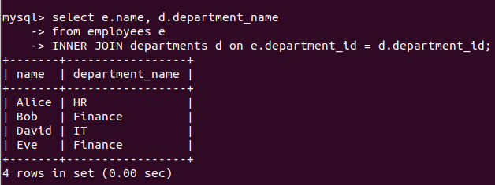

LEFT JOIN
SELECT e.name, d.department_name
FROM employees e
LEFT JOIN departments d ON e.department_id = d.department_id;

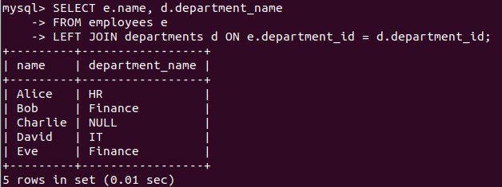

RIGHT JOIN
SELECT e.name, d.department_name
FROM employees e
RIGHT JOIN departments d ON e.department_id = d.department_id;

